***Aura New Collection belt Watches:***

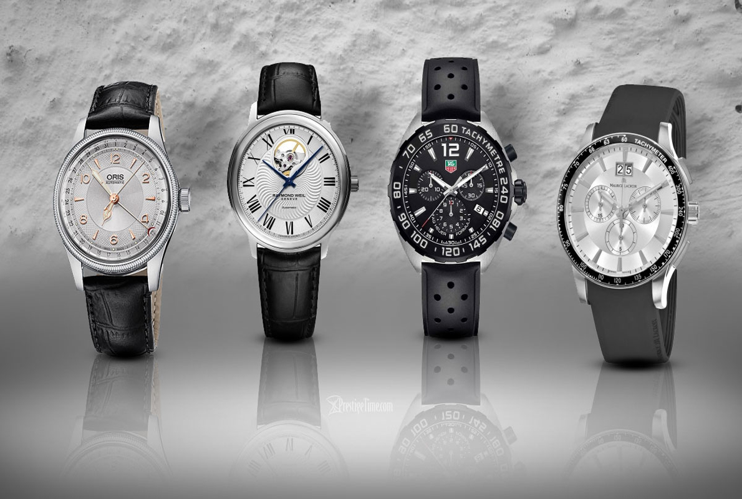

***DETAILS ABOUT THIS WATCH:***

Case: 40 mm (diameter) / 11.5mm (thickness)  
Case Material: Titanium  
Wrist fit: 6 1/4 inches - 8 1/2 inches (168-215mm), 10 holes each 5.5mm apart / 20mm width  
Wristband Material: Stainless Steel Mesh  
Battery: Renata 371 button cell watch battery

***SPACES:***

**MOV'T TYPE:**Quartz

**STRAP MATERIAL:**Mesh

**CASE SHAPE:**Round

**WATER RESISTANCE:**3 ATM

***Price:***

***Rs:5,000***